Causal Graph Disentanglement with Heterogeneous GraphSAGE for Multimodal Misinformation Detection
Author Name
University / Institution, Address, Country
Abstract. Heterogeneous Graph Neural Networks (HGNNs) represent a powerful approach to multimodal misinformation detection by simultaneously modeling multiple entity and relation types. However, current models often exploit spurious correlations rather than learning invariant mechanisms, leading to performance degradation under data distribution shifts. In datasets such as Fakeddit, this manifests as reliance on community-level label distribution history (Subreddit), a strong confounding signal that does not reflect genuine content semantics. To address this problem, this study proposes CausalHeteroGNN, an architecture grounded in Structural Causal Models (SCM) with a graph-level structural intervention that removes the identified confounding pathway. We further identify a label leakage phenomenon from FastRP structural features that can substantially bias OOD evaluation results. On the Confounding-Shift Benchmark, CausalHeteroGNN achieves 74.2% ± 3.6 OOD accuracy and 0.851 AUC, outperforming an independently trained ERM baseline (52.1%), IRM (54.1%), and EERM (59.6%), and attaining the best worst-group accuracy (37.8%). A source-history ablation attributes about 15 percentage points of this gain to domain-credibility features, with the remainder matching the content-only ceiling (59.5%), making explicit which signals the model relies on. The results demonstrate that, once a confounder has been identified, a hard structural constraint on the graph removes it more reliably than soft invariance penalties, offering a practical direction for misinformation detection systems under shifting data environments.
Keywords: HGNNs, SCM, Multimodal Misinformation Detection, GraphSAGE.

1. Introduction
The proliferation of multimedia communication has given rise to increasingly sophisticated forms of misinformation, posing significant challenges to automated detection systems. By virtue of their capacity to model multiple entity types and relationships within a unified data structure, Heterogeneous Graph Neural Networks (HGNNs) have emerged as an effective approach to this problem. Nevertheless, the majority of current models primarily learn statistical correlations present in training data rather than the mechanisms that determine the veracity of information. As a consequence, models tend to rely on environment-specific signals and suffer performance degradation when encountering communities or contexts not seen during training.
From a causal inference perspective, this phenomenon can be explained by the presence of confounding variables in the data structure. In datasets such as Fakeddit, the community label distribution history (Subreddit) often exhibits a strong correlation with post labels, forming a shortcut path between content and predicted labels. Through graph message passing, HGNNs tend to amplify these signals and learn environment-dependent patterns instead of causally invariant features. The critical question is therefore not how accurately the model performs on observed data, but whether the model maintains predictive capacity when community signals are altered or completely reversed. Although many studies have evaluated Out-of-Distribution (OOD) generalizability by withholding certain communities for test phases, these protocols are insufficient for distinguishing models that genuinely learn causal signals from those exploiting spurious correlations. To address this limitation, this study proposes a novel causal architecture along with a more rigorous evaluation protocol under confounding-shift conditions.
To address the above limitations, this study makes three main contributions: (1) proposes CausalHeteroGNN, a multimodal HGNN architecture based on SCM with a structural intervention mechanism that removes the identified confounding pathway from the message-passing graph; (2) constructs the Confounding-Shift Benchmark, an OOD evaluation protocol under reversed confounder-label correlation conditions, together with independently trained ERM, content-only MLP, IRM, and EERM baselines and a worst-group analysis; and (3) identifies the risk of label leakage from FastRP features in inductive graph learning settings and quantifies, via a source-history ablation, how much of the model's OOD performance stems from label-derived source features rather than content, ensuring the reliability and transparency of the experimental results.

2. Background and Related Works
Research on multimodal misinformation detection demonstrates that simultaneously integrating content and relational structural information significantly improves the recognition of misleading information. SAFE [12] exploits semantic consistency between text and images; BiGCN [11] models information propagation through diffusion tree structures; KGAT [14] enhances verification by integrating external knowledge from knowledge graphs; while Heterogeneous Graph Neural Networks (HGNNs) [4] allow simultaneous representation of multiple entity and relation types in a shared learning space. Despite achieving high performance on standard benchmarks, most existing studies are evaluated under settings where test data originates from the same domain as training data, leaving the generalizability under changing community structures and data environments unsystematically explored.
From a causal inference standpoint, Pearl [2] shows that distinguishing correlation from causation requires intervention and backdoor adjustment mechanisms to eliminate confounding variable effects. Building on this foundation, Schölkopf and Peters [6,9] argue that model generalizability depends on whether it has learned invariant mechanisms across multiple environments, rather than relying on correlation patterns specific to training data. Methods such as IRM and EERM [13] instantiate this idea by searching for stable representations across multiple environments or minimizing risk differences across environments constructed through graph perturbations. However, these methods still rely on soft regularization constraints, which only attenuate dependence on confounding signals rather than directly removing the confounding source from the representation learning process. When the correlation between confounder and label remains sufficiently strong, models may continue to exploit these signals to optimize in-distribution performance, thereby degrading generalizability in distribution-shift scenarios.

3. Data Collection and Representation in Neo4J
To efficiently manage and exploit a multimodal heterogeneous information network, this study employs Neo4j [15] as the graph storage and querying platform. Neo4j enables intuitive representation of heterogeneous entities and relationships while supporting structural analysis operations that serve causal model construction.
The primary data source is Fakeddit [1], a large-scale benchmark collected from Reddit during 2008–2020, comprising over one million posts with labeled text and image data. To ensure successful experimentation on limited infrastructure, this study performs training on 5,898 post samples; after graph modeling, the dataset yields 17,079 nodes and 28,274 relationships.
All data is represented as a property graph in Neo4j, consisting of five node types: Post, User, Subreddit, Domain, and Image; together with five directed relationship types: POSTED_BY, POSTED_IN, LINKS_TO, HAS_IMAGE, and MEMBER_OF (Fig. 1). The final graph comprises 5,898 Post nodes, 4,604 User nodes, 658 Domain nodes, 21 Subreddit nodes, and 5,898 Image nodes. Organizing data in graph form enables integrity verification via Cypher and directly supports graph-based analysis and representation learning steps.
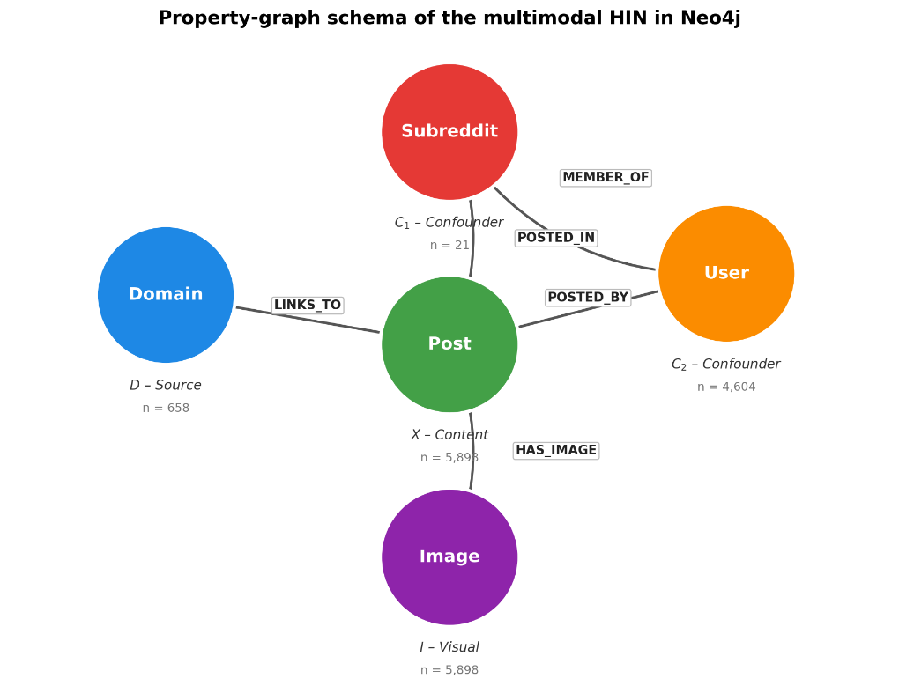
Fig. 1. Fakeddit data representation as a property graph in Neo4j.
To evaluate OOD generalizability, two communities—r/neutralnews and r/theonion—are completely excluded from training and validation, then used as the OOD test set. Accordingly, the training set comprises 5,000 posts (2,500 real and 2,500 fake), the validation set 400 posts, and the test set 498 posts, including 298 OOD samples. The validation set is used solely for hyperparameter selection, while the test set is reserved for final evaluation.
After preprocessing, each post is converted into a PyTorch Geometric HeteroData object. Post features include semantic information from titles extracted by all-mpnet-base-v2 and statistical attributes such as score, upvote ratio, and comment count; FastRP structural embeddings are deliberately excluded from the default model input because they leak label information under inductive evaluation (Section 5.4) and are retained only for the leakage analysis and the BI dashboard. Image features are extracted using CLIP ViT-B/32, while User, Subreddit, and Domain nodes are described by behavioral indices and aggregated statistical measures. To prevent label leakage, all behavioral features are computed exclusively from the training set; nodes unseen during training receive neutral default values. This graph representation serves as input to the CausalHeteroGNN model with a HeteroGraphSAGE backbone.

4. Proposed Graph Convolutional Neural Network with GraphSAGE
CausalHeteroGNN is designed with a parallel architecture in which Heterogeneous GraphSAGE serves as a shared foundational encoder for two branches: the Baseline branch receives the original graph G with all relationships intact, and the Causal branch receives the intervened graph G_causal from which all edges connected to Subreddit nodes have been removed. The two representations are disentangled via a Gradient Reversal Layer (GRL) and orthogonality constraints, then fed into binary and multi-class classification heads.
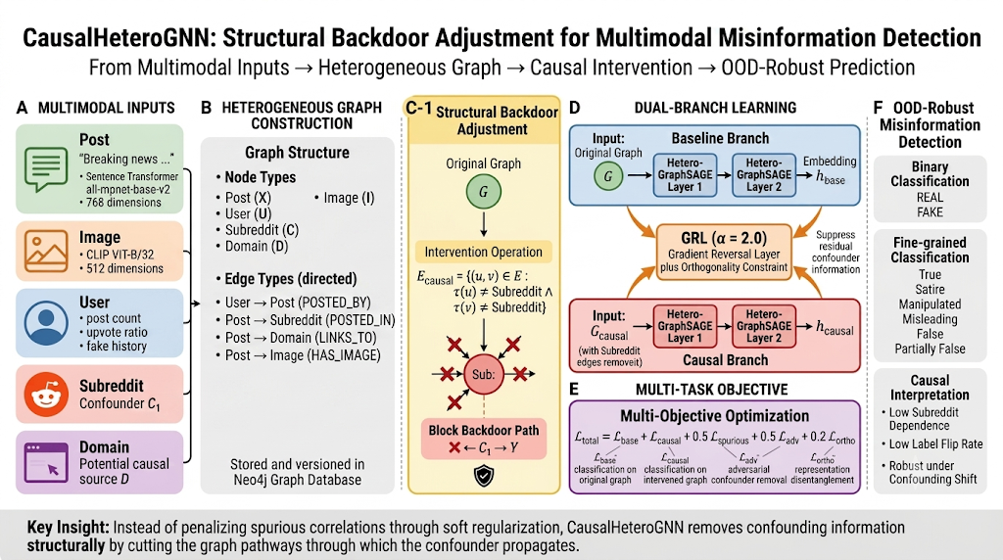
Fig. 2. CausalHeteroGNN architecture: structural backdoor intervention removes Subreddit edges to produce the causal graph G_causal; the Causal and Baseline branches are encoded in parallel, disentangled by a Gradient Reversal Layer (GRL, α = 2.0) and orthogonality constraints, under a multi-objective loss function targeting robust OOD prediction.
Since different node types have distinct feature spaces, each type is projected into a shared latent space d = 96 via independent linear transformations, followed by ReLU and dropout p = 0.4. Two Heterogeneous GraphSAGE layers then perform message passing over each relation type r ∈ R: each node’s new representation is a combination of its current state with the mean representation of its relevant neighbors, enabling learning of both local features and multi-relational context.
To eliminate the influence of the posting community as a confounding factor, we perform a structural intervention directly on the graph: in the causal branch, all edges incident on Subreddit nodes are removed:
E_causal = { (u,v) ∈ E : τ(u) ≠ Subreddit ∧ τ(v) ≠ Subreddit }
This operation blocks the backdoor path X ← C₁ → Y at the graph level, preventing the causal representation from accessing the community shortcut. We deliberately use the term structural intervention rather than full backdoor adjustment: the mechanism removes the identified confounding pathway rather than stratifying over the confounder distribution. Note also that the intervention targets only the community confounder C₁; label-history features of Domain and User nodes (e.g., source-credibility ratios computed on the training set) remain visible to the causal branch, and their contribution is quantified separately in Section 5.6. To reduce indirect leakage, a Gradient Reversal Layer (GRL) with α = 2.0 and an orthogonality constraint between the two branch representation spaces are added.
Training simultaneously optimizes predictive capability, invariance, and confounding signal elimination:
L = L_base,2w + 0.5·L_base,6w + L_causal,2w + 0.5·L_causal,6w + 0.5·L_spurious + 0.5·L_adv + 0.2·L_ortho
where L_base and L_causal are the classification losses (binary and multi-class) of the two branches; L_spurious models confounding signals; L_adv is the adversarial component from GRL; and L_ortho encourages separation of causal and non-causal representations.

5. Experiments

5.1. OOD Evaluation Protocol Setup
This study employs two evaluation protocols. (i) Held-Out-Domain (Subreddit) OOD [10]: r/neutralnews and r/theonion are withheld for testing, without intentional modification of the confounder-label relationship. (ii) Confounding-Shift Benchmark: the actual Subreddit is replaced by a synthetic binary confounding variable (spur_fakebias, spur_realbias); each post is assigned according to its true label with probability ρ. The training/seen phase uses ρ = 0.9 (strong correlation); the OOD phase uses ρ = 0.1 (reversed), creating a ColoredMNIST-style shift [8, 10] that forces models to rely on stable signals. The two protocols use different inference modes by design: Held-Out-Domain evaluation is inductive and content-only (all edges incident on test posts are masked, so each test post is classified solely from its own features, removing the subreddit-membership shortcut that would otherwise inflate transductive accuracy), whereas the Confounding-Shift Benchmark is evaluated transductively with full message passing, since its purpose is precisely to expose models to the reversed confounder. Model selection uses the validation set, which in the Confounding-Shift setting follows the training correlation (ρ = 0.9), i.e., no oracle access to the shifted distribution is assumed.

5.2. Evaluation Criteria
CausalHeteroGNN is compared against four independently trained baselines using identical data, splits, hidden size, number of layers, and training procedure: (i) Baseline GNN (ERM) — a plain HeteroGraphSAGE classifier on the original graph with no invariance mechanism; (ii) MLP — a content-only classifier over post features without any message passing, serving as a graph-free anchor; (iii) IRM (λ = 100), learning invariant features across subreddit-partitioned environments; and (iv) EERM, using 3 virtual environments generated by random edge perturbation with a maximum probability of 0.3 (a practical variant of the original REINFORCE-based environment generator [13]). Performance is evaluated using Accuracy, Macro-F1, AUC, Worst-Group Accuracy, and Label-Flip Rate (LFR), reported as mean ± std over three random seeds.

5.3. Main Results
On the Held-Out-Domain (Subreddit) protocol, all methods achieve comparable performance (56.9%–60.9%), and notably the graph-free MLP (60.5%) is on par with all GNN variants — indicating that for entirely unseen communities the graph contributes little beyond content quality, and that this protocol does not provide sufficient pressure to reveal differences in confounder-handling strategies. In contrast, on Confounding-Shift the gap becomes pronounced (Table 1, Fig. 3).
Table 1. Classification performance on two OOD protocols (mean ± std over 3 seeds). Baseline GNN is an independently trained ERM HeteroGraphSAGE; MLP is a graph-free content-only classifier. The Seen Acc column and Confounding-Shift columns are taken from the ρ = 0.9 → 0.1 setting.
Model | Seen Acc | Held-Out OOD | Conf-Shift OOD | AUC | F1 Drop
MLP (content-only) | 81.7±0.6 | 60.5 | 59.5±1.7 | 0.685 | 30.0%
Baseline GNN (ERM) | 91.0±0.4 | 57.6 | 52.1±7.8 | 0.511 | 45.1%
IRM | 91.2±0.2 | 56.9 | 54.1±4.7 | 0.524 | 43.2%
EERM | 93.2±0.2 | 60.9 | 59.6±1.1 | 0.694 | 38.6%
CausalHeteroGNN | 83.8±0.5 | 57.7 | 74.2±3.6 | 0.851 | 12.7%
Baseline GNN (ERM) achieves 91.0% in-distribution accuracy but drops to 52.1% with AUC 0.511 when the community correlation is reversed — it loses essentially all discriminative power, performing no better than random. IRM (54.1%) and EERM (59.6%) mitigate the degradation but do not exceed the content-only ceiling set by the MLP (59.5%). CausalHeteroGNN reaches 74.2% with AUC 0.851 and the smallest Macro-F1 drop (12.7%), and also attains the best worst-group accuracy (37.8%, vs. 28.6% for EERM, 24.4% for IRM, and 23.5% for ERM): all soft-penalty methods collapse on the group whose correlation is reversed (fake posts in the real-biased environment) — the characteristic signature of shortcut reliance. As an additional diagnostic, the baseline branch co-trained inside CausalHeteroGNN, which the disentanglement objective explicitly encourages to absorb spurious signal, collapses to 36.4% with AUC 0.314 < 0.5, i.e., a systematically inverted decision boundary. Notably, CausalHeteroGNN has lower Seen Acc (83.8%) — consistent with the hypothesis that restricting exploitation of community signals trades short-term in-distribution performance for OOD robustness.
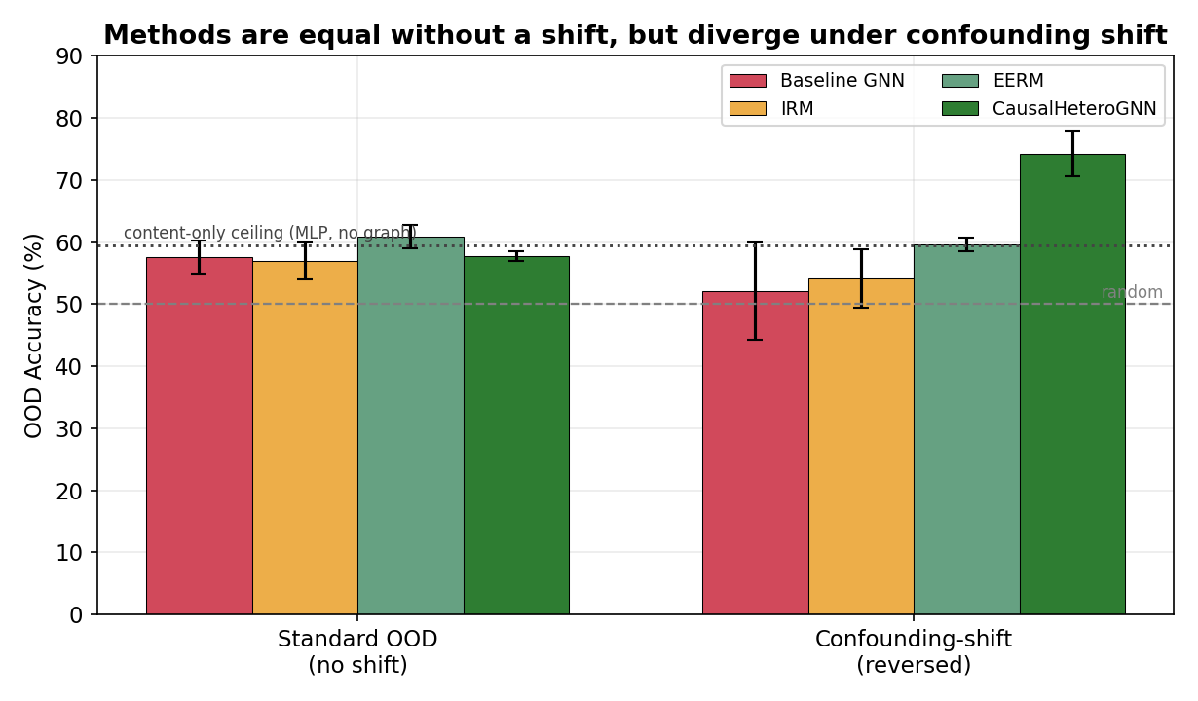
Fig. 3. Comparison of OOD accuracy between the Held-Out-Subreddit and Confounding-Shift protocols (mean ± std over 3 seeds). Baseline GNN is the independently trained ERM; the dotted line marks the content-only ceiling (MLP, no graph).
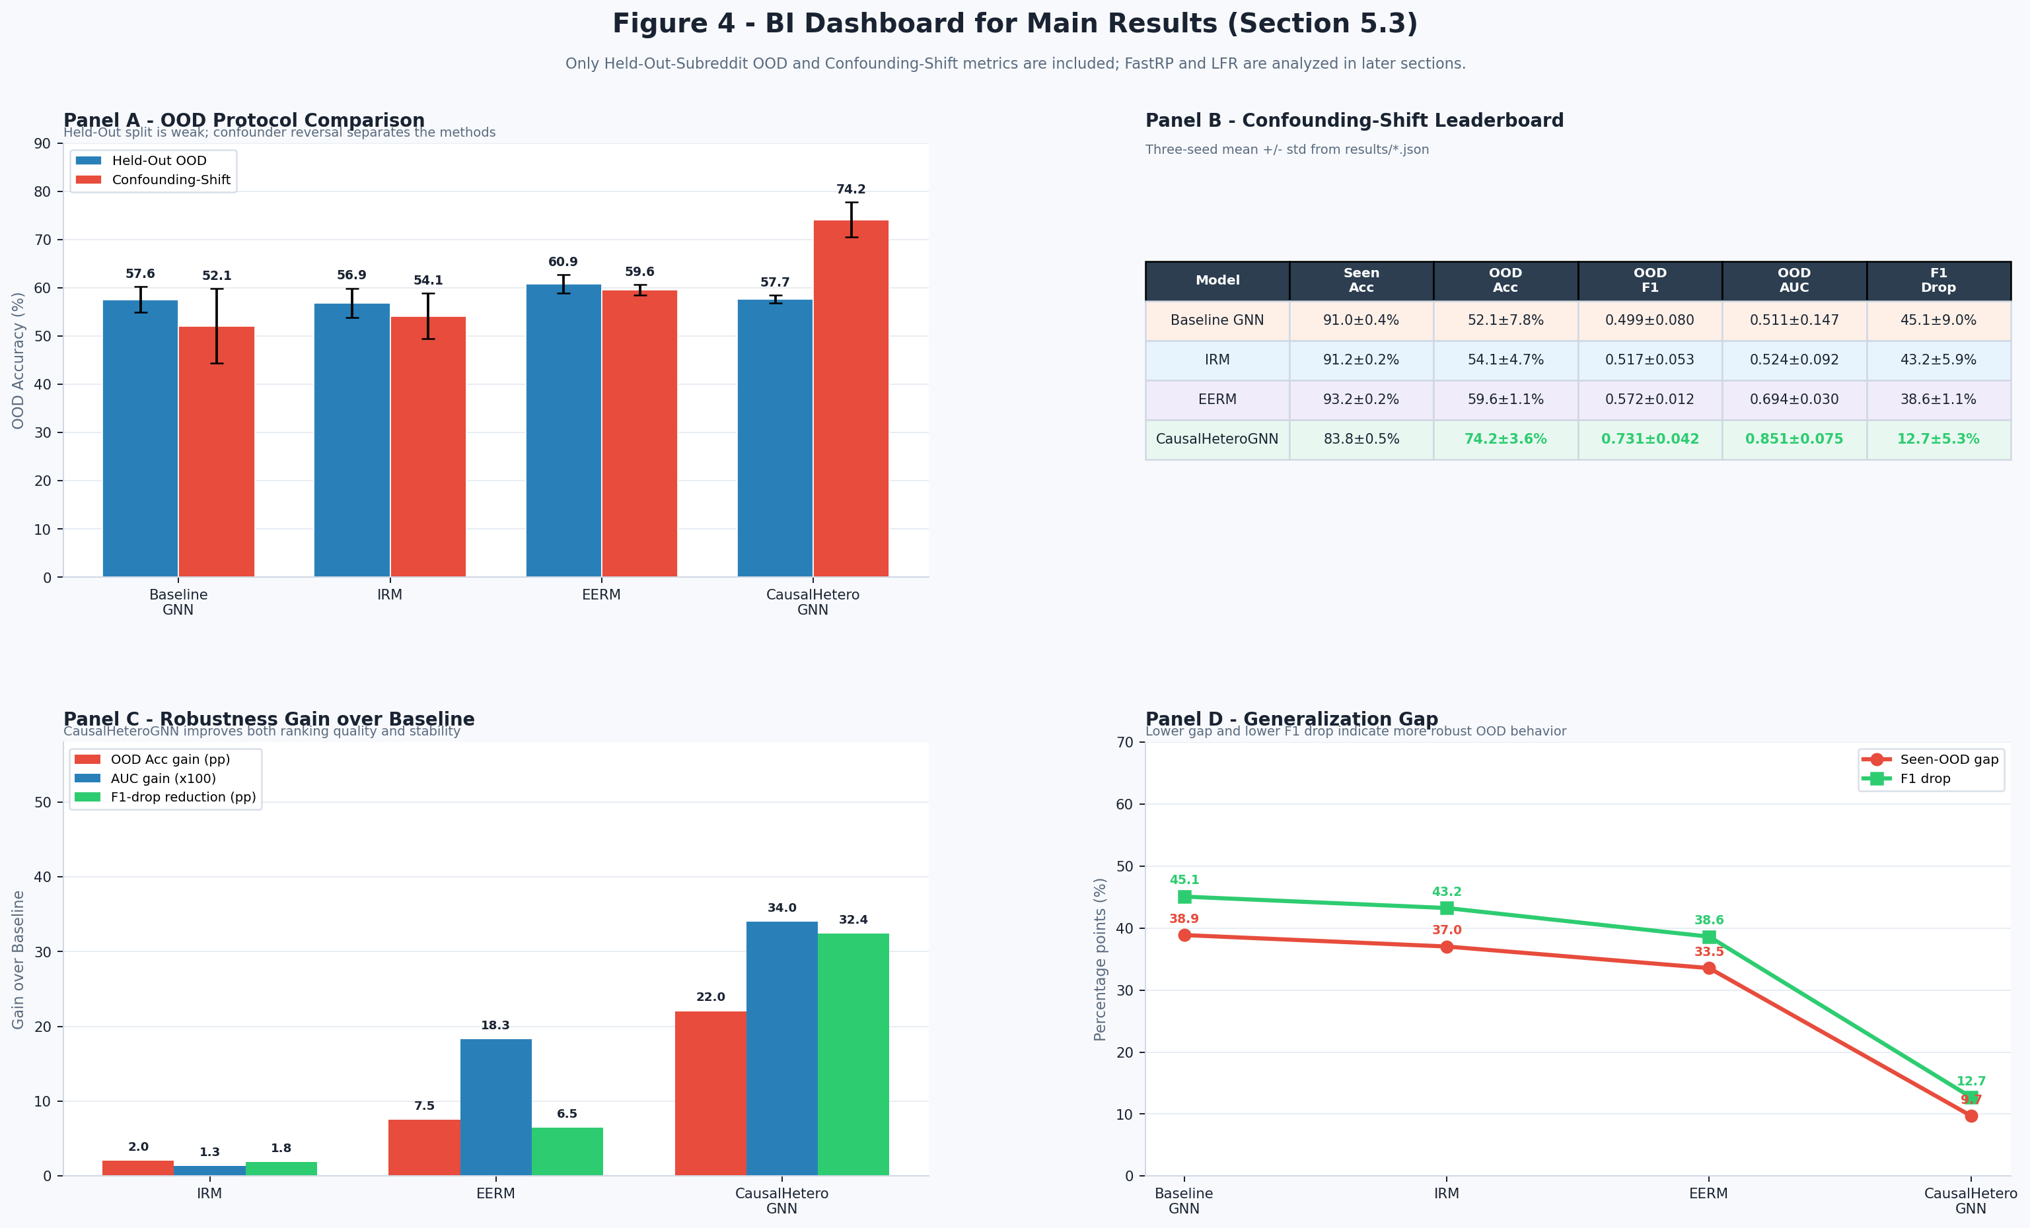
Fig. 4. Summary dashboard of main results across two OOD protocols. Metrics are averaged over three seeds; Baseline GNN is the independently trained ERM HeteroGraphSAGE. Held-Out-Subreddit shows comparable performance across models, while Confounding-Shift reveals the degradation of ERM and the advantages of CausalHeteroGNN in OOD Accuracy, AUC, Macro-F1 Drop, and Seen-OOD gap.

5.4 FastRP Feature Leakage Analysis
When retaining FastRP features in GNN inputs, both Baseline and CausalHeteroGNN achieve OOD accuracies of 93.6% ± 1.7% and 94.3% ± 1.9% respectively, with AUC ≈ 0.980 and F1-drop near zero (−0.1%)—results that appear ideal but are in fact the product of label leakage. Analysis reveals that FastRP is computed by Neo4j GDS over the entire graph prior to train–test splitting, so global structural information (correlated with community and labels) is indirectly encoded into the 64-dimensional input vectors of each OOD post, enabling the GNN to correctly classify by structural cluster rather than content. When FastRP is removed to ensure a truly inductive setting (text embedding + scalar features only), OOD performance drops to 61.0% ± 2.1% (Baseline) and 61.1% ± 1.6% (CausalHeteroGNN), with corresponding AUC falling to 0.630 and F1-drop rising to 25.1% and 25.2%—accurately reflecting the true difficulty of the task. The gap between the two configurations reaches +32.7 percentage points (Baseline) and +33.2 percentage points (Causal), demonstrating that all OOD performance gains when using FastRP stem from structural leakage, not genuine model generalizability.
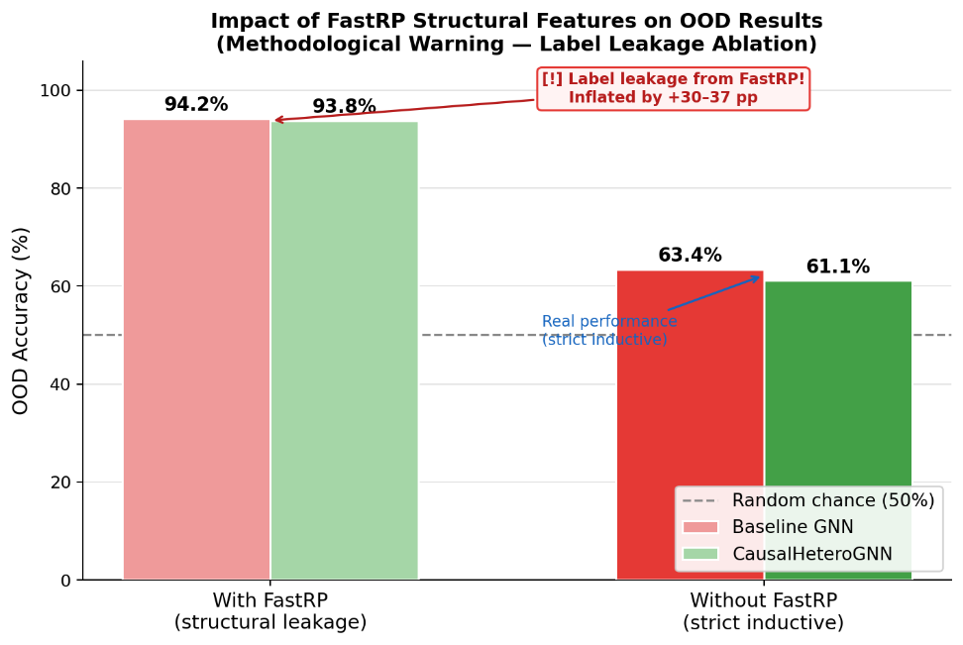
Fig. 5. Impact of FastRP structural feature leakage on OOD results.

5.5 Structural Intervention Analysis via Label-Flip Rate (LFR)
This study performs do(·) interventions on the causal graph and measures the rate of model prediction changes (Label-Flip Rate).
Table 2. Label-Flip Rate (LFR) under structural interventions.
Intervention | LFR Baseline | LFR Causal | Interpretation
do(C₁ = swap) | 30.1% | ~0.0% | Community swap — sanity check (invariant by construction)
do(I = ∅) | 4.0% | 8.0% | Remove image features
do(D = credible) | 6.2% | 15.5% | Change source credibility

The causal branch is invariant to community swapping (≈0.0%) by construction, since all Subreddit edges are removed; we therefore report this value as a sanity check confirming that the intervention works as intended, rather than as an empirical finding. The Baseline, in contrast, responds strongly to community swapping (30.1%). The causal branch is more sensitive to image interventions (4.0% → 8.0%) and source credibility (6.2% → 15.5%), indicating that after community dependence is removed, the model relies more heavily on content and source information — consistent with the source-history ablation in Section 5.6.
  - 5.6 Source-History Ablation and the Content-Only Ceiling
To quantify exactly which signals drive CausalHeteroGNN's OOD performance, we neutralize the label-derived source-history feature — the Domain fake-ratio computed on the training set — by replacing it with a constant 0.5 and retraining on the Confounding-Shift Benchmark. OOD accuracy drops from 74.2% ± 3.6 to 58.8% ± 2.9 and AUC from 0.851 to 0.681, attributing approximately 15.4 percentage points of the headline result to source-credibility history; the remainder coincides with the content-only ceiling established by the MLP (59.5%). This decomposition makes the model's reliance explicit: the structural intervention fully removes the community confounder, while absolute performance additionally rests on source-history features — a legitimate and useful signal in deployment, but one that would degrade under a shift in the domain distribution. We report this decomposition openly rather than presenting the 74.2% figure as purely content-based generalization.

6 Conclusion
This study proposed CausalHeteroGNN, a causally-oriented Heterogeneous GraphSAGE model for multimodal misinformation detection. By identifying the Subreddit as a confounding variable and removing its information pathways in the causal branch, the model eliminates the community shortcut by construction — more reliably than soft invariance penalties.
Results on the Confounding-Shift Benchmark show that CausalHeteroGNN achieves 74.2% OOD Accuracy and 0.851 AUC, surpassing the independently trained ERM baseline (52.1%), IRM (54.1%), and EERM (59.6%), with the best worst-group accuracy (37.8%) and the smallest Macro-F1 drop (12.7%). A source-history ablation attributes ~15 percentage points of this result to domain-credibility features, with the remainder matching the content-only ceiling (MLP, 59.5%) — an explicit decomposition of what the model relies on.
This study further demonstrates that FastRP can cause information leakage in OOD evaluation when computed over the entire graph prior to train–test splitting. The main open limitation is content-based satire detection: on the held-out protocol, all evaluated models remain weak on the r/theonion group (29–44% accuracy), and on entirely unseen communities the graph contributes little beyond content features. Future work may address satire-aware content modeling, extend the evaluation to additional datasets and confounders (including source-level shifts), and develop the BI dashboard into a tool for model analysis and auditing.

References
- Nakamura, K., Levy, S., Wang, W.Y.: r/Fakeddit: A new multimodal benchmark dataset for fine-grained fake news detection. In: Proc. 12th Lang. Resour. Eval. Conf. (LREC), pp. 6149–6157. Marseille, France (2020).
- Pearl, J.: Causality: Models, Reasoning, and Inference, 2nd edn. Cambridge Univ. Press, Cambridge, U.K. (2009).
- Hamilton, W.L., Ying, R., Leskovec, J.: Inductive representation learning on large graphs. In: Advances in Neural Information Processing Systems (NeurIPS), pp. 1024–1034 (2017).
- Hu, Z., Dong, Y., Wang, K., Sun, Y.: Heterogeneous graph transformer. In: Proc. Web Conf. (WWW), pp. 2704–2710 (2020).
- Ganin, Y., et al.: Domain-adversarial training of neural networks. J. Mach. Learn. Res. 17(59), 1–35 (2016).
- Schölkopf, B.: Causality for machine learning. In: Probabilistic and Causal Inference: The Works of Judea Pearl, pp. 765–804. ACM, New York, NY, USA (2022).
- Ying, R., Bourgeois, D., You, J., Zitnik, M., Leskovec, J.: GNNExplainer: Generating explanations for graph neural networks. In: Advances in Neural Information Processing Systems (NeurIPS), pp. 9240–9251 (2019).
- Arjovsky, M., Bottou, L., Gulrajani, I., Lopez-Paz, D.: Invariant risk minimization. arXiv:1907.02893 (2019).
- Peters, J., Janzing, D., Schölkopf, B.: Elements of Causal Inference: Foundations and Learning Algorithms. MIT Press, Cambridge, MA, USA (2017).
- Gulrajani, I., Lopez-Paz, D.: In search of lost domain generalization. In: Proc. Int. Conf. Learn. Representations (ICLR) (2021).
- Bian, T., Xiao, X., Xu, T., Zhao, P., Huang, W., Rong, Y., Huang, J.: Rumor detection on social media with bi-directional graph convolutional networks. In: Proc. AAAI Conf. Artif. Intell., vol. 34, no. 01, pp. 549–556 (2020).
- Zhou, X., Wu, J., Zafarani, R.: SAFE: Similarity-aware multi-modal fake news detection. In: Proc. Pacific-Asia Conf. Knowl. Discovery Data Mining (PAKDD), pp. 354–367 (2020).
- Wu, Q., Zhang, H., Yan, J., Wipf, D.: Handling distribution shifts on graphs: An invariance perspective. In: Proc. Int. Conf. Learn. Representations (ICLR) (2022).
- Liu, Z., Xiong, C., Sun, M., Liu, Z.: Fine-grained fact verification with kernel graph attention network. In: Proc. 58th Annu. Meeting Assoc. Comput. Linguistics (ACL), pp. 7342–7351 (2020).
- Robinson, I., Webber, J., Eifrem, E.: Graph Databases: New Opportunities for Connected Data, 2nd edn. O’Reilly Media, Sebastopol, CA, USA (2015).

